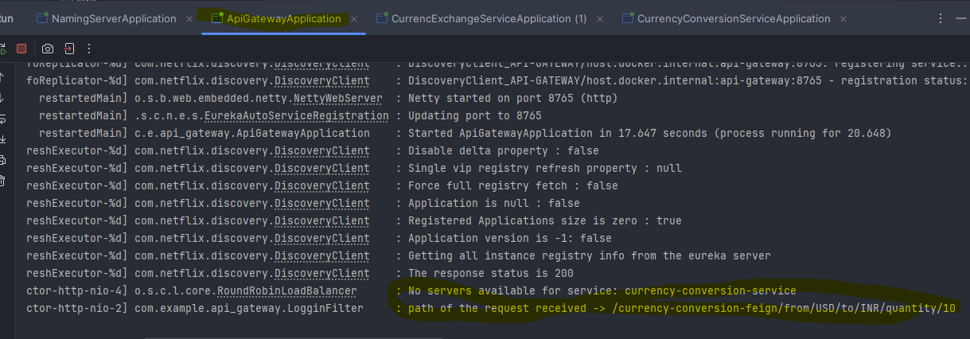

To get above highlighted logs below the filter class needs to be added in the project

*package* com.example.api_gateway;  
  
*import* org.slf4j.Logger;  
*import* org.slf4j.LoggerFactory;  
*import* org.springframework.cloud.gateway.filter.GatewayFilterChain;  
*import* org.springframework.cloud.gateway.filter.GlobalFilter;  
*import* org.springframework.stereotype.*Component*;  
*import* org.springframework.web.server.ServerWebExchange;  
*import* reactor.core.publisher.Mono;  
  
*@Component  
public class* LogginFilter *implements* GlobalFilter {  
 *private* Logger logger = LoggerFactory.getLogger(LogginFilter.*class*);  
 *@Override  
 public* Mono<Void> filter(ServerWebExchange exchange, GatewayFilterChain chain) {  
 logger.info("path of the request received -> {}",exchange.getRequest().getPath());  
 *return* chain.filter(exchange);  
 }  
}

